STUDENT NAME: GEORGE AMOAH
COURSE: DATA COMMUNICATION
STUDENT ID: PUIT24210025
CONTENTS
1. INTRODUCTION .................................................................................................... 1
- 1.1 Evolution of satellite communication and
- 1.2 It’s role in the modern global data infrastructure.
2. TECHNICAL PRINCIPLES OF SATELLITE COMMUNICATION ..................... 12
- 2.1 Orbital Mechanics: Physics of the Vacuum
  - 2.1.1 Low Earth Orbit (LEO)
  - 2.1.2 Medium Earth Orbit (MEO)
  - 2.1.3 Geostationary Orbit (GEO)
- 2.2 Frequency Spectrum Management
  - 2.2.1 C, Ku, and Ka Bands
- 2.3 Signal Modulation and Link Budgets
3. SATELLITE ZOOMING: HIGH-THROUGHPUT SPOT BEAM TECHNOLOGY ... 28
- 3.1 Architecture of High-Throughput Satellites (HTS)
- 3.2 The Mechanism of "Satellite Zooming"
- 3.3 Frequency Reuse and Capacity Optimization
- 3.4 Precision and Targeted Data Acquisition
4. COMPARATIVE ANALYSIS: SATELLITE VS. TERRESTRIAL SYSTEMS ......... 45
- 4.2 Advantages and Disadvantages of Satellite
- 4.3 Terrestrial data communication System
5. ARCHITECTURAL CHALLENGES AND CONSTRAINTS .................................. 58
- 5.1 Atmospheric Attenuation
- 5.2 Latency
- 5.3 Orbital Debris
- 5.4 Cybersecurity
6. FUTURE TRENDS AND INNOVATIONS............................................................. 7
- 6.1 Integration with 6G Mobile Networks
- 6.2 AI-Driven Autonomous Satellite Operations
7. REFERENCES (APA 7th Edition) ........................................................................... 85
1 INTRODUCTION
Since the launch of the first artificial satellite in 1957, satellite communication has evolved into a cornerstone of modern global infrastructure. Today, satellites facilitate television and radio broadcasting, maritime and aviation communication, environmental monitoring, and precision navigation—services that billions of people depend upon daily (Lutz et al., 2012). This paper traces the development of satellite communications from its theoretical foundations to contemporary implementations, with a primary focus on commercially oriented advancements. While the contributions of space agencies such as NASA and the European Space Agency (ESA) have been foundational, the scope of this work is directed toward commercial and civilian applications.
A defining characteristic of satellite communication is the broad geographic coverage it provides. Unlike terrestrial networks, satellites can serve remote and economically unviable regions where ground-based infrastructure is impractical (Evans et al., 2005). Moreover, satellites can complement terrestrial systems rather than compete with them, offering redundancy, rapid deployment, and coverage in disaster-prone areas where ground systems may fail. These complementary capabilities form the basis for the growing convergence of satellite and terrestrial networks in modern communication architectures.
In the 65 years since its inception satellite communications has been, and still is today, a vital key part of peoples everyday life – receiving TV and radio; providing essential communications to remote land areas and on the sea or in the air; allowing us to see and predict our climate / environment as well as allowing us to actively position and navigate. This paper attempts to chart the progress of satellite communications from early concepts and visions to modern day implementations. Indeed, over a few decades, progress in all satellite communications field has been quite intense. In this paper we mainly focused upon commercial service oriented developments, regretfully neglecting most of the tremendous work achieved in NASA and ESA as well as in other space agencies, which nonetheless certainly had important impact and influence on most of the developments we will discuss. The intensive and comprehensive work relating to defense related satellite communications has been also given a light touch as will be seen from later material. To those who have made major contributions in these areas, we apologize in advance. The two major advantages of satellites for communications lie in their wide coverage (hence the predominance of broadcast application), which means they can reach areas that are uneconomic for terrestrial provision, and their ability to quickly install new services over the slower terrestrial roll out. The latter should not be misconstrued as a competition between satellite and terrestrial, but an opportunity for them to be complementary and synergistic. In comparison with terrestrial systems, satellites have stringent constraints in terms of power and allocated spectrum, which can make them less attractive in some scenarios. In essence, both can be useful to provide cost efficient communications to the user, and system design will drive the selection depending on the contingent requirements. In this paper, we will develop the overview of satellite communications considering early visions, international systems, broadcasting, mobile communications, and broadband satellite access. In our discussion, we will run across seven decades classified as follows:
− 1940-50’s—the decade of visions of satellite communications;
− 1950-60’s---the realization of the visions and the early experimentation;
− 1960-70’s---the era of the large International organizations and transoceanic links;
− 1970-80’s---the introduction of broadcast and mobiles and the move to company use;
− 1980-90’s---from national to individual usage and liberalization;
− 1990-2000—innovations in business use and constellations as well as Geostationary Earth Orbits (GEOs); − 2000-2010----privatization and focus onto new technologies;
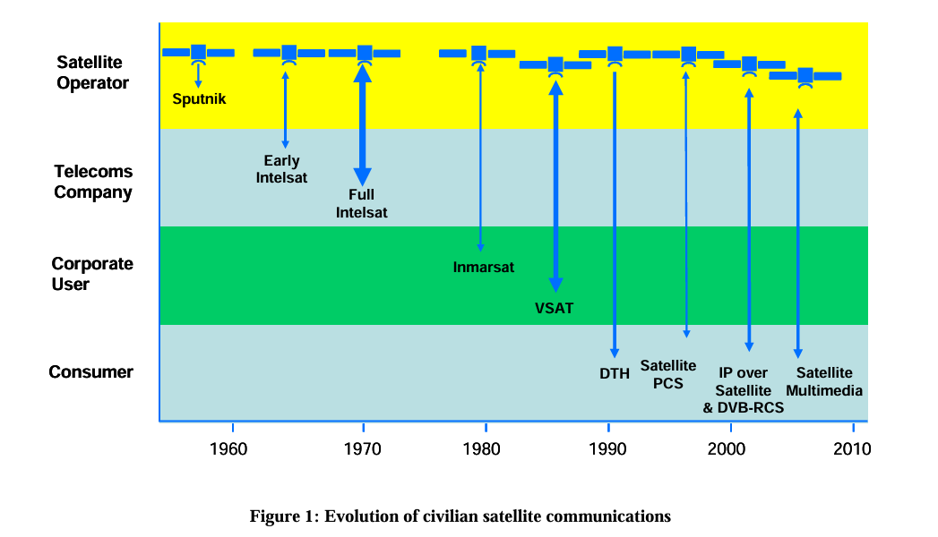
  - EVOLUTION OF SATELLITE COMMUNICATION

The theoretical origins of satellite communication are widely attributed to Arthur C. Clarke, whose 1945 paper in Wireless World proposed the use of three geostationary relay stations to enable global communication (Clarke, 1945). Clarke had previously circulated a paper to the British Interplanetary Society titled 'The Space Station: Its Radio Applications,' in which he articulated the concept of synchronous orbital platforms. His vision proved remarkably prescient: today, hundreds of uncrewed geostationary satellites serve commercial and military purposes, many with operational lifespans exceeding fifteen years.
Clarke was not alone in envisioning satellite-based communication. John Pierce of Bell Laboratories independently explored the concept in 1954, evaluating both passive reflector satellites and active repeater designs across medium and geostationary orbits (Pierce, 1968). Pierce concluded at the time that practical implementation was constrained not by communications technology, but by the absence of sufficiently powerful launch vehicles—a constraint resolved in the mid-1960s through intercontinental ballistic missile development.
The concept of satellite communications is normally accredited to an Englishman, Sir Arthur C. Clarke, because of a famous paper [1] published in the British publication called ‘Wireless World’. However, Dr. Clarke produced at least two documents prior to this in which elements of the idea of satellite communications were presented. He published a letter [2] in the ‘Letters to the Editor’ column of ‘Wireless World’ on ‘Peacetime uses for V2’ in February 1945 in which he postulates an ‘artificial satellite’ in a 24 hour orbit and even goes on to suggest the use of three such satellites at 120 degree spacing. Modestly, he finishes the article with “I’m afraid this isn’t going to be of the slightest use to our post war planners, but I think is the ultimate solution to the problem.” He wrote a more extensive paper on 25 May 1945 entitled ‘The space station: its radio applications’ which he circulated to several council members of the British Interplanetary Society (whose motto is aptly From imagination to reality) who gave it their whole-hearted support. The top copy is now in the archives of the Smithsonian Institute in Washington DC and a facsimile is published in ‘How the World was One’ [3] along with a copy of his later and now famous Wireless World paper of October 1945. In this paper Arthur C. Clarke proposed that three communications stations be placed in synchronous 24-hour orbit which could form a global communications system and make worldwide communications possible. The communications equipment would be installed and operated in a space station where it would be maintained by its crew. To date, we have seen hundreds of unstaffed
communications satellites launched 5 into geosynchronous orbit for commercial and military use, with the newest spacecraft lasting fifteen or more years without maintenance. Sir Arthur C. Clarke was not the only person thinking about communications satellites. In 1946, the US Army’s Project Rand pointed out in a classified study the potential commercial use of synchronous communications satellites. Unfortunately, this report remained secret for so long that it had little impact. In 1954, John Pierce [4] of Bell Laboratories considered the communications satellite problem independently of Clarke. To Pierce there seemed little reason at that time to replace overland cables or terrestrial microwave relays with satellites. There were two general possibilities for such satellites: passive reflectors that would bounce the radio waves between ground antennas, and active repeaters which would amplify the received signal and retransmit it to the ground. Either kind of satellite could be placed in medium-altitude orbits, requiring a constellation of many satellites and steerable antennas on the ground, or one satellite in synchronous orbit, where it would appear to remain stationary at one location. It seemed to Pierce that nothing practical could be done to facilitate satellite communications, although the communications equipment was not the problem. The invention of the transistor, the solar cell and the travelling-wave tube (TWT) amplifier in the 1940s and 1950s allowed relatively compact highly reliable repeaters to be built. The difficulty was the rockets. It was not until the development of suitable launch vehicles that these concepts could be realized. Launch vehicles of the power required became available in the mid 1960s as a by-product of the military development of the intercontinental ballistic missile.
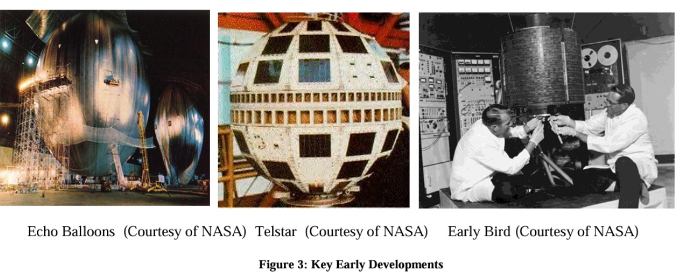
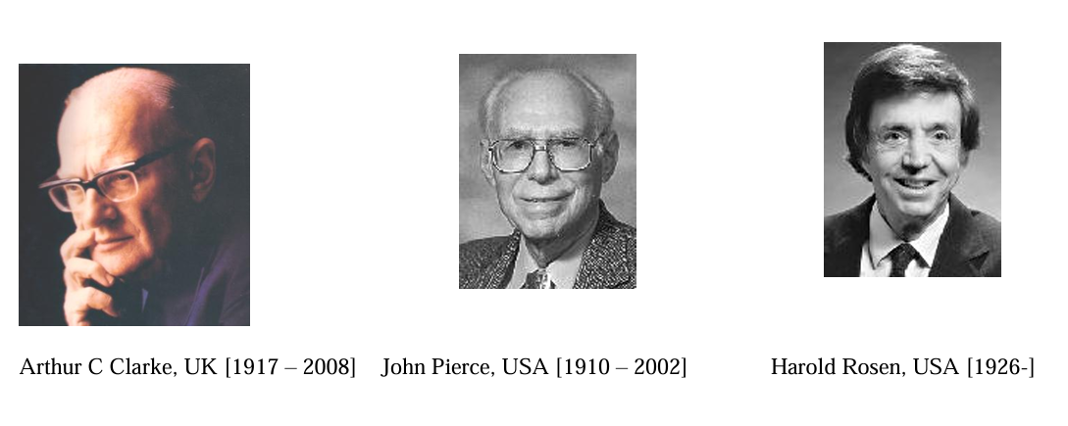
Figure 2: Key people-Visionaries and Pioneers

Figure 2: Key people-Visionaries and Pioneers 6 Several private companies in the United States, including RCA and Lockheed in the early 1950s, investigated the possibility of communications satellites before the government became interested. The Hughes Aircraft Company spent company money from 1959 to 1961 to demonstrate the feasibility of a design for synchronous satellites before convincing NASA and the USA Defense Department to fund the rest of the project. However, by far the greatest activity was in AT&T’s Bell Telephone Laboratories. The V-2 was the catalyst for the artificial unmanned satellite. In the days of early rocketry researchers concentrated on manned flight. There was also skepticism regarding radio waves penetrating the upper atmosphere. More important, in those years of radio valves, there simply was no adequate electronic technology. For these reasons, radiocommunications studies are conspicuously absent from the early astronautical literature. Beginning in 1945, given the large-scale rocket technology, wartime advances in electronics and the development of transistors, proposals for satellites started to be published [1],[5]. In 1955 Radio Moscow had announced a prospective satellite launch, but this was not taken seriously. On 29 July 1955 the USA announced that it would ‘launch small earth-circling satellites’ as part of its contribution to the International Geophysical Year (Project Vanguard) [6]. On 4 October 1957, the Soviets launched SPUTNIK 1. It was not until the 31 January 1958 that America launched its first satellite, the Explorer 1, but the USSR countered this by launching a 3 tons ‘flying laboratory’, and thus the space race had begun. It was to be the space race that accelerated the development of the technology and the will to launch satellites into space. However, it was only when the race settled down that worthy application satellites began to be developed and launched, riding on the spin-offs from the race. It is worth noting that Arthur C. Clarke’s book ‘How the World was One’ [3] was ‘Dedicated to the real fathers of the communications satellite, John Pierce and Harold Rosen, by the godfather’. It is therefore reasonable to assume that Dr. Clarke was the initial visionary and others, especially these two, were pioneers. Both had the backing of significant commercial organizations behind them (AT&T and Hughes 7 Aircraft Company, respectively) and therefore had the resources to push the pioneering efforts required at that time. The early days of satellite communications comprised many experiments and fact-finding missions which eventually led to the active transponder-based satellites in common use today. The background of these early days is too extensive to detail here but Table 1 gives some basic information on these activities [7].

INTELSAT:
In 1962 the United States, Canada and the United Kingdom held discussions on forming an international satellite organization based upon the concept established in the US Congress Communications Satellite Act of 1962 [11]. Later discussions, in 1963, were expanded to include most of the European countries. Serious negotiations were begun in Rome in February 1964 at which participants included representatives from Western Europe, the USA and Canada. Shortly thereafter, Australia and Japan were included, recognizing that together these countries accounted for some 85 per cent of the world’s international telephone traffic. In the remarkably brief period of just over six months, two agreements entered into force and the new international entity, INTELSAT, was created. These interim arrangements came into force for the 11 founder members in August 1964. Definite arrangements came into force on 12 February 1973. The role of INTELSAT undertook major changes in the late 1990s and early 2000s, when it was released from the legacy of being an intergovernmental organization (which, however, promoted interesting technical developments, as per [12]) and allowed to operate as a private company in a free market [13]. This came about when, following representations from the private industry, the US congress passed the Open Market Reorganization for the Betterment of International Telecommunications (ORBIT) Act to privatize the international organization. Thus in July 2001 INTELSAT became a private company. Rather ironically, in July 2006 it acquired Panamsat which was one of the leading proponents / competitors in the privatization era. INTELSAT has based its corporate headquarters in Luxembourg, with a majority of staff located at the INTELSAT offices in Washington, DC.
EUTELSAT:
In 1964, the European Conference on Satellite Communications (CETS), which was originally created to coordinate a European position in the INTELSAT negotiations, began to focus attention on a possible European satellite programme. The objective of this work was to give Europe, and in particular its industry, technical capability in this area based on an experimental satellite programme. 1966 saw the formation and first meeting of the European Space Conference (ESC), designed to harmonize the work of the different European bodies dealing with space activities. The European satellite programme under study was originally conceived for the provision of Eurovision television programmes for the European Broadcasting Union (EBU) as well as some telephony in Europe and the Mediterranean basin. In August 1970, a European telecommunications satellite working group (SET) was established to collaborate with ESRO/ELDO (the two organizations later merged in the European Space Agency, ESA) in carrying out studies in this area. At the December 1971 ESRO/ELDO Council meeting this was approved and work on the experimental satellite, to be known as the Orbital Test Satellite (OTS), commenced at the end of 1972. The operational phase satellites were to be known as the European Regional Communications Satellite System (ECS). In March 1977, a conference was held to prepare for the establishment of an interim organization to manage the space segment, called Interim EUTELSAT. As a result an agreement was entered into force on 30 June 1977. OTS–2 was successfully launched on 11 May 1978 (after an unsuccessful attempt in September 1977) and was to be utilized initially for three years. However, on the completion of three years in orbit, the satellite was still working properly, and special financial arrangements were concluded with ESA to keep it there. In 1979 Interim EUTELSAT began to consider arrangements for the definitive organization. After much debate the definitive agreements entered into force on 20 July 1985. ECS flight 1 was successfully launched on 16 June 1983 and followed by four more in the period up to July 1988. Unfortunately, flight 3 suffered a launch failure in 1985. 12 The period 1983–1984 witnessed considerable activity in the field of future programmes. The initial system was unable to adequately provide sufficient capacity beyond 1990 with the resources available under the EUTELSAT-ESA arrangement. It was concluded that this situation could be addressed by procuring enhanced satellites which could be available for operation by the end of 1989. The first of the Eutelsat-II satellite was launched in January 1991 with more to follow shortly. In 1995, EUTELSAT provided the first digital TV broadcast in Europe using the Digital Video Broadcasting (DVB) standard. In line with the general telecommunications deregulation globally EUTELSAT was privatized in July 2001.
INMARSAT
Since the early XX century, the Safety of Life at Sea (SOLAS) Convention enforced the use of wireless communications for all ships beyond a certain tonnage. It was first issued after the Titanic disaster, and it had a natural evolution from radio-telegraphy towards radio-telephony and then to satellite communications. In 1966 the International Maritime Organisation (IMO), based in London, undertook studies on the possibility of satisfying the communication needs of the maritime mobile service (MMS) by the use of satellite communications and the need to provide radio frequencies for this purpose. In 1967 the International Telecommunication Union (ITU) World Administrative Radio Conference (WARC) for the MMS adopted a recommendation relating to the utilization of space communication techniques in the MMS outlining further work to be conducted prior to the 1971 WARC. Following the allocation of frequencies to MMS service by WARC 1971, it was decided that studies should be undertaken to establish an organization and introduction of an international maritime satellite system in full cooperation with the telecommunication authorities of its member governments. Three conferences would be needed before the INMARSAT convention was adopted in September 1976 and the formal INMARSAT organization was established on 16 July 1979. The UK government was a prime mover in all aspects of establishing INMARSAT. It funded the early European-based MARECS system to the tune of 39 per cent of the total and made way for the establishment of the INMARSAT headquarters in London.
Role in Modern Global Data Infrastructure:
Satellite communication now forms a critical pillar of global data infrastructure, complementing terrestrial networks and enabling connectivity in remote or underserved regions. Projects like Starlink, OneWeb, and Telesat deploy LEO constellations to provide high-speed internet worldwide, bridging the digital divide and supporting applications from broadband access to IoT networks and defense communications. Satellites also facilitate 5G/6G integration, allowing seamless convergence of space-based and terrestrial networks for universal coverage. Emerging technologies, including quantum communication, inter-satellite links, and dynamic beam hopping, promise to further enhance global connectivity and network resilience.

2. TECHNICAL PRINCIPLES OF SATELLITE COMMUNICATION
- 2.1 Orbital Mechanics: Physics of the Vacuum
  - 2.1.1 Low Earth Orbit (LEO)
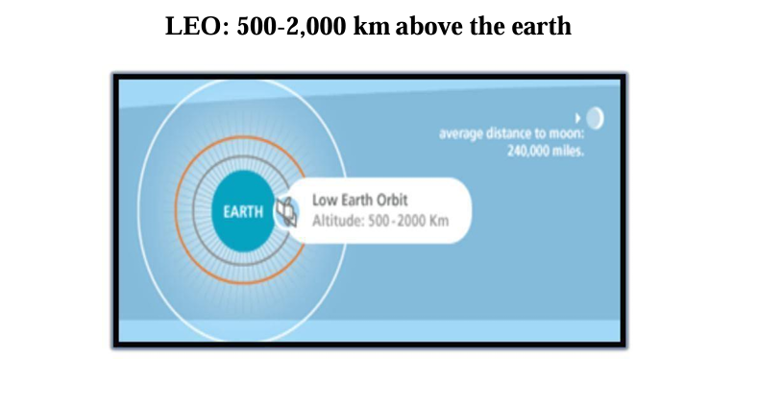
Low Earth Orbit (LEO) satellites: These satellites are placed 500-1500 kms above the surface of the earth. As LEOs circulate on a lower orbit, hence they exhibit a much shorter period that is 95 to 120 minutes. LEO systems try to ensure a high elevation for every spot on earth to provide a high quality communication link. Each LEO satellite will only be visible from the earth for around ten minutes. Using advanced compression schemes, transmission rates of about 2,400 bit/s can be enough for voice communication. LEOs even provide this bandwidth for mobile terminals with Omni directional antennas using low transmit power in the range of 1W. The delay for packets delivered via a LEO is relatively low (approx 10 ms). The delay is comparable to long-distance wired connections (about 5–10 ms). Smaller footprints of LEOs allow for better frequency reuse, similar to the concepts used for cellular networks. LEOs can provide a much higher elevation in Polar Regions and so better global coverage. These satellites are mainly used in remote sensing an providing mobile communication services (due to lower latency). Disadvantages: The biggest problem of the LEO concept is the need for many satellites if global coverage is to be reached. Several concepts involve 50–200 or even more satellites in orbit. The short time of visibility with a high elevation requires additional mechanisms for connection handover between different satellites. The high number of satellites combined with the fast movements resulting in a high complexity of the whole satellite system. One general problem of LEOs is the short lifetime of about five to eight years due to atmospheric drag and radiation from the inner Van Allen belt1. Assuming 48 satellites and a lifetime of eight years, a new satellite would be needed every two months. The low latency via a single LEO is only half of the story. Other factors are the need for routing of data packets from satellite to if a user wants to communicate around the world. Due to the large footprint, a GEO typically does not need this type of routing, as senders and receivers are most likely in the same footprint

Advantages of LEO
• A LEO satellite’s proximity to earth compared to a GEO satellite gives it a better signal strength and less of a time delay, which makes it better for point to point communication.
• A LEO satellite’s smaller area of coverage is less and waste of bandwidth.
Disadvantages of LEO
• A network of LEO satellites is needed, which can be costly
• LEO satellites have to compensate for Doppler shifts cause by their relative movement.
• Atmospheric drag effects LEO satellites, causing gradual orbital deterioration.
  - 2.1.2 Medium Earth Orbit (MEO)
Medium Earth Orbit (MEO) satellites: MEOs can be positioned somewhere between LEOs and GEOs, both in terms of their orbit and due to their advantages and disadvantages. Using orbits around 20,000 km, the system only requires a dozen satellites which is more than a GEO system, but much less than a LEO system. These satellites move more slowly relative to the earth’s rotation allowing a simpler system design (satellite periods are about six hours). Depending on the inclination, a MEO can cover larger populations, so requiring fewer handovers.
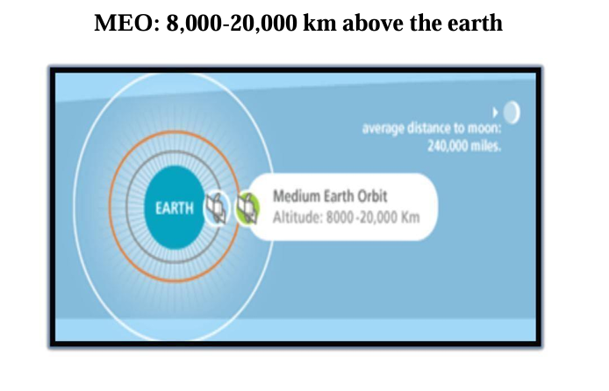
Disadvantages: Again, due to the larger distance to the earth, delay increases to about 70–80 ms. the satellites need higher transmit power and special antennas for smaller footprints.

Advantages of MEO
• A MEO satellite’s longer duration of visibility and wider footprint means fewer satellites are needed in a MEO network than a LEO network.
Disadvantages of MEO
• A MEO satellite’s distance gives it a longer time delay and weaker signal than a LEO satellite, though not as bad as a GEO satellite.

  - 2.1.3 Geostationary Orbit (GEO)
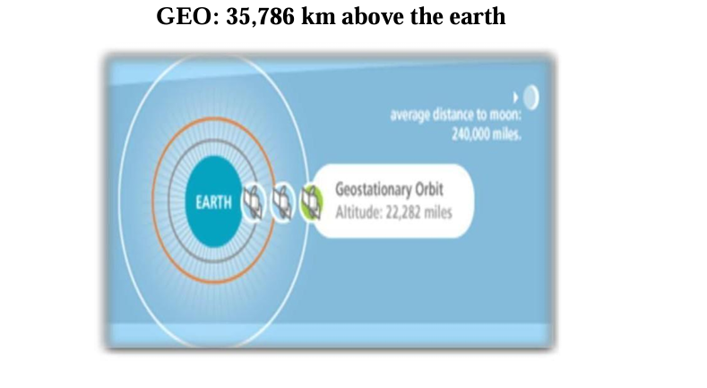
Geostationary or geosynchronous earth orbit (GEO): GEO satellites are synchronous with respect to earth. Looking from a fixed point from Earth, these satellites appear to be stationary. These satellites are placed in the space in such a way that only three satellites are sufficient to provide connection throughout the surface of the Earth (that is; their footprint is covering almost 1/3rd of the Earth). The orbit of these satellites is circular. There are three conditions which lead to geostationary satellites. Lifetime expectancy of these satellites is 15 years. 1) The satellite should be placed 35,786 kms (approximated to 36,000 kms) above the surface of the earth. 2) These satellites must travel in the rotational speed of earth, and in the direction of motion of earth, that is eastward. 0 3) The inclination of satellite with respect to earth must be 0 . Geostationary satellite in practical is termed as geosynchronous as there are multiple factors which make these satellites shift from the ideal geostationary condition. 1) Gravitational pull of sun and moon makes these satellites deviate from their orbit. Over the period of time, they go through a drag. (Earth’s gravitational force has no effect on these satellites due to their distance from the surface of the Earth.) 2) These satellites experience the centrifugal force due to the rotation of Earth, making them deviate from their orbit. 3) The non-circular shape of the earth leads to continuous adjustment of speed of satellite from the earth station. These satellites are used for TV and radio broadcast, weather forecast and also, these satellites are operating as backbones for the telephone networks. Disadvantages of GEO: Northern or southern regions of the Earth (poles) have more problems receiving these satellites due to the low elevation above a latitude of 60°, i.e., larger antennas are needed in this case. Shading of the signals is seen in cities due to high buildings and the low elevation further away from the equator limit transmission quality. The transmit power needed is relatively high which causes problems for battery powered devices. These satellites cannot be used for small mobile phones. The biggest problem for voice and also data communication is the high latency as without having any handovers, the signal has to at least travel 72,000 kms. Due to the large footprint, either frequencies cannot be reused or the GEO satellite needs special antennas focusing on a smaller footprint. Transferring a GEO into orbit is very expensive.

Advantages of GEO Satellites
Persistent Coverage: The most significant advantage of GEO satellites is their ability to provide persistent, uninterrupted coverage over a specific area. This makes them invaluable for critical applications that require stable, continuous connectivity, such as broadcasting live television signals, facilitating long-distance telecommunication links, and supporting weather forecasting models.
Wide Area Coverage: A single GEO satellite can cover approximately one-third of the Earth’s surface, allowing for extensive coverage with fewer satellites. This wide area of coverage is particularly beneficial for creating efficient, large-scale communication networks and broadcasting services that can reach a vast audience across entire continents.
High Capacity and Reliability: GEO satellites are equipped with powerful transponders capable of handling high bandwidths, making them ideal for supporting the backbone of international telecommunications, including voice, data, and video transmissions. Their stationary nature reduces the risk of signal loss or interruption, providing a reliable platform for critical communication infrastructure.

- 2 Frequency Spectrum Management
  - 2.2.1 C, Ku, and Ka Bands
C-band satellite communication operates within the frequency range of 4 GHz to 8 GHz, primarily used for reliable data transmission, television broadcasting, and telecommunications.
Frequency Range
The C band is defined by its frequency ranges:
Downlink Frequencies: 3.7 to 4.2 GHz (from satellite to ground station)
Uplink Frequencies: 5.925 to 6.425 GHz (from ground station to satellite
Advantages of C-Band
Reduced Rain Fade: C-band frequencies are less susceptible to rain fade compared to higher frequency bands, making them more reliable in adverse weather conditions.
Cost-Effective Bandwidth: C-band bandwidth is generally cheaper than other frequency bands, making it a cost-effective choice for many applications.
Mature Technology: C-band technology has been in use for decades, leading to well-established infrastructure and easier installation of satellite systems.
Applications
C-band satellite communication is widely used in various applications, including:
Television Broadcasting: Many television networks utilize C-band for satellite transmission, ensuring wide coverage and reliable service.
VSAT (Very Small Aperture Terminal): C-band is commonly used for VSAT applications, providing internet and data services to remote locations.
Weather Radar Systems: C-band frequencies are also employed in weather radar systems to detect and track precipitation.
Comparison with Other Bands
While C-band is one of the oldest and most widely used frequency bands in satellite communication, it is often compared with Ku-band and Ka-band, which offer higher data rates but may be more susceptible to weather-related disruptions. C-band remains a preferred choice in regions with high rainfall or where cost is a significant factor.
Ku-band refers to frequencies from 12 GHz to 18 GHz, while Ka-band refers to frequencies from 26.5 GHz to 40 GHz. Increasing the frequency on a Ka-band system can get more bandwidth, which means a higher data transfer rate.
The Ku-band (12–18 GHz) is a primary microwave spectrum range used extensively in satellite communication for Direct-to-Home (DTH) television, VSAT networks, and high-speed satellite broadband. It enables smaller, more portable antennas compared to C-band, though it is more susceptible to rain attenuation.
Key Aspects of Ku-Band Satellite Communication
Frequency Range: Covers 12 to 18 GHz, specifically, uplink is usually around 14 GHz and downlink spans 10.7–12.75 GHz.
Applications:
DTH TV: Used by providers like DirecTV and Bell TV to broadcast to smaller home dishes.
VSAT Networks: Used for corporate networks, satellite news gathering (SNG), and maritime communications.
Broadband Internet: Used for internet services, including those from LEO (Low Earth Orbit) satellites.
Advantages:
Smaller Equipment: Higher frequencies allow for smaller dishes and components.
High Capacity: Provides high data rates.
Lower Costs: Generally more cost-effective for end users, according to Get SAT.
Limitations:
Rain Fade: Highly susceptible to signal degradation during heavy rain.
Equipment: Uses LNBs (Low Noise Block downconverters) to downconvert signals for transmission to a receiver.
The Ku-band, or "K-under," is frequently used for space-to-ground communication, such as NASA’s Tracking Data Relay Satellite for the ISS.

Ka-band satellite communications operate in the 26.5–40 GHz range, offering high data rates and bandwidth for broadband, military, and deep-space applications.
Frequency and Spectrum
The Ka-band is a portion of the microwave spectrum spanning roughly 26.5 to 40 GHz, sitting above the Ku-band (12–18 GHz) and below the V-band (40–75 GHz) in the electromagnetic spectrum. For satellite communications, the uplink frequencies typically range from 27.5 to 31 GHz, while downlink frequencies are in the 17.7 to 21.2 GHz range. This high frequency allows for smaller antennas and higher bandwidth, enabling faster data transmission compared to lower-frequency bands like Ku or C-band.
Advantages
Ka-band offers several benefits for satellite communications:
High Data Rates: Supports broadband internet, high-throughput satellite (HTS) services, and advanced military communications.
Smaller Equipment: Smaller dish sizes are sufficient due to higher frequency, reducing ground terminal costs and footprint.
High Capacity: Enables multi-gigabit throughput for GEO, MEO, and LEO satellites, supporting dense coverage areas.
Flexibility: Modern Ka-band satellites, like Viasat’s ViaSat-3 series, use electronically and mechanically steered beams to dynamically allocate bandwidth for mobile and fixed users.
Limitations
Despite its advantages, Ka-band has some challenges:
Rain Attenuation: Signals are more susceptible to rain and atmospheric moisture than Ku or C-band, which can reduce reliability in adverse weather.
Higher Cost: Equipment and satellite payloads are generally more expensive due to advanced technology requirements.
Line-of-Sight Requirement: High-frequency signals require clear line-of-sight between the satellite and ground terminals.
Applications
Ka-band is widely used across multiple satellite orbits:
Geostationary Orbit (GEO): High-throughput satellites like Inmarsat I-5, Kacific K-1, and ViaSat-1, 2, 3 provide broadband internet and government communications.
Medium Earth Orbit (MEO): Systems like SES O3b and O3b mPOWER deliver low-latency connectivity for enterprise and government users.
Low Earth Orbit (LEO): SpaceX Starlink, Iridium Next, and planned Amazon Kuiper constellations use Ka-band for high-speed internet and global coverage.
Military and Government: Ka-band networks, such as Viasat’s unified Ka-band system, provide secure, high-capacity communications for air, land, and sea operations, with interoperability across commercial and MILSATCOM satellites.
Deep Space and Scientific Missions: Used for high-data-rate downlinks from missions like the Kepler and James Webb Space Telescope.
Comparison with Other Bands
Ku-band (12–18 GHz): Less affected by rain, widely deployed for TV broadcasting and VSATs, but offers lower data rates and requires larger antennas.
X-band (7–8 GHz): Primarily military, highly resilient to weather, but limited bandwidth for broadband applications.
Ka-band: Optimal for high-speed broadband, smaller terminals, and high-capacity networks, though more sensitive to weather conditions.
Ka-band represents the current standard for high-throughput satellite communications, balancing bandwidth, speed, and terminal size, and is increasingly adopted for both commercial broadband and government/military applications worldwide
- 2.3 Signal Modulation and Link Budgets
In satellite communication systems, there are two types of power calculations. Those are transmitting power and receiving power calculations. In general, these calculations are called as Link budget calculations. The unit of power is decibel.
First, let us discuss the basic terminology used in Link Budget and then we will move onto explain Link Budget calculations.
Basic Terminology
An isotropic radiator (antenna) radiates equally in all directions. But, it doesnt exist practically. It is just a theoretical antenna. We can compare the performance of all real (practical) antennas with respect to this antenna.
Power flux density
Assume an isotropic radiator is situated at the center of the sphere having radius, r. We know that power flux density is the ratio of power flow and unit area.
Power flux density,Ψi
of an isotropic radiator is
Ψi=ps4πr2
Where, Ps
is the power flow. In general, the power flux density of a practical antenna varies with direction. But, its maximum value will be in one particular direction only.
Antenna Gain
The gain of practical antenna is defined as the ratio of maximum power flux density of practical antenna and power flux density of isotropic antenna.
Therefore, the Gain of Antenna or Antenna gain, G is
G=ΨmΨi, Where, Ψm is the maximum power flux density of practical antenna. And, Ψi is the power flux density of isotropic radiator (antenna).
Equivalent Isotropic Radiated Power
Equivalent isotropic radiated power (EIRP) is the main parameter that is used in measurement of link budget. Mathematically, it can be written as
EIRP=GPs
We can represent EIRP in decibels as
[EIRP]=[G]+[Ps]dBW
Where, G is the Gain of Transmitting antenna and Ps is the power of transmitter.
Transmission Losses
The difference between the power sent at one end and received at the receiving station is known as Transmission losses. The losses can be categorized into 2 types.
Constant losses
Variable losses
The losses which are constant such as feeder losses are known as constant losses. No matter what precautions we might have taken, still these losses are bound to occur.
Another type of loses are variable loss. The sky and weather condition is an example of this type of loss. Means if the sky is not clear signal will not reach effectively to the satellite or vice versa.
Therefore, our procedure includes the calculation of losses due to clear weather or clear sky condition as 1st because these losses are constant. They will not change with time. Then in 2nd step, we can calculate the losses due to foul weather condition.
Link budget calculations
There are two types of link budget calculations since there are two links namely, uplink and downlink.
Earth Station Uplink
It is the process in which earth is transmitting the signal to the satellite and satellite is receiving it. Its mathematical equation can be written as (CN0)U=[EIRP]U+(GT)U−[LOSSES]U−K
Where,[CN0] is the carrier to noise density ratio, [GT] is the satellite receiver G/T ratio and units are dB/K
Here, Losses represent the satellite receiver feeder losses. The losses which depend upon the frequency are all taken into the consideration.
The EIRP value should be as low as possible for effective UPLINK. And this is possible when we get a clear sky condition.
Here we have used the (subscript) notation U, which represents the uplink phenomena.
Satellite Downlink
In this process, satellite sends the signal and the earth station receives it. The equation is same as the satellite uplink with a difference that we use the abbreviation D everywhere instead of U to denote the downlink phenomena.
Its mathematical equation can be written as;
[CN0]D=[EIRP]D+[GT]D−[LOSSES]D−K
Where,
[CN0] is the carrier to noise density ratio
[GT] is the earth station receiver G/T ratio and units are dB/K
Here, all the losses that are present around earth stations.
In the above equation we have not included the signal bandwidth B. However, if we include that the equation will be modified as follows.
[CN0]D=[EIRP]D+[GT]D−[LOSSES]D−K−B
Link Budget
If we are taking ground satellite in to consideration, then the free space spreading loss (FSP) should also be taken into consideration.
If antenna is not aligned properly then losses can occur. so we take AML (Antenna misalignment losses) into account. Similarly, when signal comes from the satellite towards earth it collides with earth surface and some of them get absorbed. These are taken care by atmospheric absorption loss given by AA and measured in db.
Now, we can write the loss equation for free sky as
Losses=FSL+RFL+AML+AA+PL
Where,
RFL stands for received feeder loss and units are db.
PL stands for polarization mismatch loss.
Now the decibel equation for received power can be written as
PR=EIRP+GR+Losses
Where,
PR, stands for the received power, which is measured in dBW.
Gr is the receiver antenna gain.
The designing of down link is more critical than the designing of uplink. Because of limitations in power required for transmitting and gain of the antenna.

3. SATELLITE ZOOMING: HIGH-THROUGHPUT SPOT BEAM TECHNOLOGY
- 3.1 Architecture of High-Throughput Satellites (HTS)

High-Throughput Satellites (HTS) represent a significant generational advance over conventional Fixed Satellite Service (FSS) platforms, delivering data throughput capacities from two to over one hundred times greater than traditional satellites within the same allocated orbital spectrum (Fenech et al., 2015). The defining architectural innovation of HTS is the replacement of a single wide-area beam with a large number of narrowly focused spot beams, each covering a small geographic cell analogous to a terrestrial mobile network.
This spot beam architecture provides three compounding advantages. First, it enables aggressive frequency reuse, as non-adjacent beams can share the same frequency and polarisation without causing harmful interference. Second, the narrower beamwidth concentrates transmitted power, increasing link margins and allowing the use of smaller user terminals. Third, the combination of frequency reuse and enhanced link margins supports the deployment of higher-order modulation and coding schemes (MODCODs), which yield greater spectral efficiency—measured in bits per second per hertz of spectrum—and thus higher aggregate throughput (Fenech et al., 2015). While Ka-band has become the most common frequency range for HTS deployments, HTS architectures have also been implemented in Ku-band, demonstrating the technology's frequency flexibility.

3.2 The Mechanism of Satellite Zooming
The concept of 'satellite zooming' refers to the ability of advanced antenna systems to concentrate and redirect electromagnetic energy toward specific geographic targets, effectively increasing the resolution and intensity of coverage in areas of demand. This capability is realised through high-gain reflectarray and parabolic antenna designs, as well as electronically steerable phased arrays that can redirect beams dynamically without mechanical movement (Imbriale et al., 2011).
In small satellite applications, origami-inspired foldable reflectarray antennas have been developed to achieve high antenna gain within the physical constraints of CubeSat platforms. These antennas can be compactly stowed during launch and deployed once in orbit, enabling small satellites to sustain data links at rates previously possible only with large spacecraft. Such innovations are particularly relevant for Earth observation, disaster monitoring, and space-based internet relay applications (Imbriale et al., 2011).

3.3 Frequency Reuse and Capacity Optimisation
Frequency reuse is the primary mechanism by which HTS systems achieve their dramatically higher throughput compared to FSS satellites. By assigning the same frequency bands to spatially separated spot beams, a satellite can multiply the effective utilisation of its licensed spectrum allocation (Fenech et al., 2015). The reuse factor N defines the number of distinct frequency and polarisation combinations required before the assignment pattern repeats across the beam lattice. A lower reuse factor increases per-beam data rates but demands greater spatial isolation between co-channel beams, while a higher factor reduces interference at the cost of lower spectral efficiency.
Modern HTS systems employ a range of techniques to optimise capacity. Fractional frequency reuse (FFR) assigns different sub-bands to beam centre and edge zones, balancing throughput against inter-beam interference. Advanced beamforming algorithms, including lattice optimisation methods such as MASCONDS, maximise the co-channel distance within multibeam lattice configurations across GEO, MEO, and LEO satellite architectures. Dynamic resource allocation—adjusting beam power, bandwidth, and modulation in response to traffic demand—further enhances efficiency in heterogeneous service environments (Kyrgiazos et al., 2014).

3.4 Precision and Targeted Data Acquisition
Precision data acquisition in satellite systems depends on Acquisition, Pointing, and Tracking (APT) subsystems that establish and maintain accurate optical or radio links between platforms. In free-space optical communications, APT delays must be precisely modelled to account for prior link geometry, initial pointing uncertainty, and the scale of platform motion (Hemmati, 2009). For shipborne and airborne applications, ATP systems have demonstrated successful acquisition and tracking of LEO satellites in dynamic environments, representing a significant capability for maritime broadband and airborne relay missions.
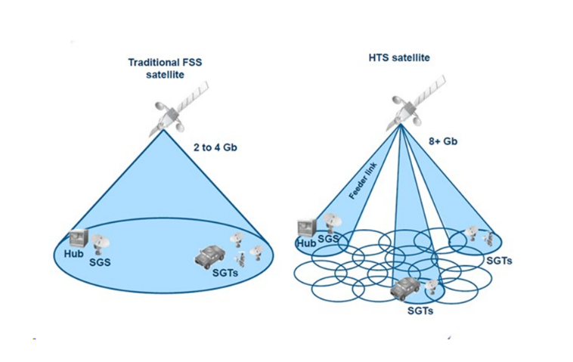
Error correction and adaptive control strategies are integral to maintaining link accuracy under dynamic conditions. Systems employing four-quadrant detectors and integrated optical phased arrays have demonstrated rapid link establishment and handover between LEO satellites, enabling near-continuous coverage for mobile platforms. These advances in precision pointing are foundational to the ongoing development of inter-satellite laser link networks and space-based internet infrastructure (Hemmati, 2009).


4. COMPARATIVE ANALYSIS: SATELLITE VS. TERRESTRIAL SYSTEMS
4.2 Advantages and Disadvantages of Satellite
The single most important thing a satellite can do that no terrestrial network can match is provide coverage over areas where building ground infrastructure is either impossible or economically unjustifiable. A single geostationary satellite illuminates roughly a third of Earth's surface simultaneously — ocean, desert, jungle, and city alike. For maritime operators, airlines, remote mining and energy companies, and military users who need reliable communications regardless of location, this geographic independence is not just convenient but essential (Evans et al., 2005).
Satellites are also uniquely suited to broadcast applications. Sending the same signal to millions of receivers simultaneously costs roughly the same as sending it to one, which is why satellite remains the dominant distribution method for live television in markets where cable and fibre penetration is incomplete. And during a natural disaster, when terrestrial infrastructure may be damaged or overwhelmed, a satellite link can often be established within hours using portable ground equipment — something a destroyed cell tower or severed fibre cable cannot match.
The weaknesses are real too. Building and launching a satellite is expensive — costs run into hundreds of millions of dollars for a large GEO platform — and the satellite must generate revenue for fifteen or more years to recover that investment. Spectrum and orbital slots are finite and internationally regulated, which creates competitive dynamics that can constrain new entrants. For geostationary satellites in particular, the half-second round-trip delay rules out a significant class of applications. And while LEO constellations solve the latency problem, they introduce a different set of challenges around handover management, inter-satellite routing, and the sheer volume of hardware needed to maintain the constellation over time.

4.2 Terrestrial Communication Systems
Terrestrial networks — fibre optic cables, copper, microwave links, cellular towers — carry the overwhelming majority of the world's data traffic today, and for good reason. In dense urban areas, fibre can deliver symmetrical gigabit speeds with latencies below five milliseconds, at costs per bit that satellite simply cannot match. The infrastructure is also far easier to maintain, upgrade, and repair when something goes wrong (Stallings, 2019).
The limitation is geography. Fibre follows roads and population centres. Running a cable to a village with two hundred people two hundred kilometres from the nearest exchange is rarely economically viable for a private operator. Cellular networks have much better reach, but they still require towers, backhaul, and power — infrastructure that gets progressively harder to justify in thinly populated areas. This is precisely the gap that satellite operators are positioning themselves to fill, not by competing with terrestrial broadband where it exists, but by extending connectivity to the places it has never reached.
Table 1: Comparative Overview of Satellite and Terrestrial Communication Systems

Parameters | Satellite communication | Terrestrial communication
Communication medium | Satellites installed in space | Physical infrastructure on the ground (Cables, fiber optics, microwave links)
Coverage | Global coverage wide across (1/4) th of the earth | Limited to specific geographical regions or within range of physical infrastructure
Latency | Higher as signals travel longer distances (120 ms from earth to satellite and 120ms from satellite to earth back) | Lower as signals travel shorter distances
Susceptibility to Signal interference | Prone to atmospheric conditions and signal blockage | Vulnerable to physical disruptions and electromagnetic interference
Mobility | Suitable for remote and mobile communication | Mostly fixed and limited mobility
Initial cost | Higher | Lower
Data speed | Usually lower compared to some terrestrial options | Higher especially using advanced fiber optic networks
Reliability | Susceptible to space related issues such as solar radiation | More reliable in stable environments with periodic maintenance
Examples | GPS, satellite TV, Satellite internet, Satellite telephony | Cellular networks, wifi, ethernet, fiber optic cables

5. ARCHITECTURAL CHALLENGES AND CONSTRAINTS
Atmospheric Attenuation
Atmospheric attenuation refers to the degradation of signal strength as electromagnetic waves propagate through the atmosphere between a satellite and an Earth station. At frequencies above 10 GHz—particularly in the Ku and Ka bands—rain-induced attenuation becomes a dominant impairment. Raindrops scatter and absorb microwave energy, with the severity of attenuation (A) described by:
A = γ · L
where γ is the specific attenuation coefficient (a function of frequency and rain rate) and L is the path length through precipitation (ITU-R P.838, 2005). Additional contributors to attenuation include atmospheric gases (primarily water vapour and oxygen), fog, and tropospheric scintillation. Mitigation strategies include adaptive coding and modulation (ACM), site diversity (routing traffic through a ground station in a different weather region), and uplink power control (ULPC), which dynamically increases transmit power to compensate for measured fade (Pratt et al., 2003).

5.2 Latency
Propagation delay is an inherent physical constraint of satellite communication, determined by the time required for signals to travel between ground terminals and the satellite. For GEO satellites at approximately 35,786 kilometres altitude, one-way propagation delay is roughly 250 milliseconds, yielding round-trip latencies of 500 to 600 milliseconds (Pratt et al., 2003). This delay is incompatible with applications such as interactive voice, online gaming, and certain financial trading platforms. MEO satellites reduce round-trip latency to approximately 125 milliseconds, while LEO satellites at 550 to 600 kilometres altitude can achieve round-trip delays of 20 to 40 milliseconds—approaching the performance of terrestrial broadband networks (Del Portillo et al., 2019). Residual latency in LEO systems is further affected by inter-satellite routing, ground network handovers, and signal processing at gateways.

5.3 Orbital Debris
The accumulation of non-operational satellites, spent rocket stages, and fragmentation debris in Earth orbit represents an escalating risk to operational spacecraft. Even centimetre-scale debris fragments travel at orbital velocities of up to 28,000 km/h, capable of causing catastrophic damage upon impact (ESA, 2023). For satellite communication systems, debris poses the threat of antenna and sensor damage, complete satellite loss, and the consumption of limited propellant in avoidance manoeuvres—each reducing service reliability and operational lifespan.
The Kessler Syndrome, first described by NASA scientist Donald Kessler in 1978, describes a cascade scenario in which debris collisions generate additional fragments, exponentially increasing the debris population until certain orbital regimes become effectively unusable (Kessler & Cour-Palais, 1978). Mitigation measures mandated by international guidelines include post-mission disposal of satellites within 25 years of end-of-life, passivation of residual propellants, and active debris removal missions currently under development by multiple space agencies and private entities (ESA, 2023).
Cybersecurity: As satellite networks increasingly underpin critical infrastructure—including financial services, defence operations, transportation navigation, and emergency response—they have become high-value targets for cyber attacks. The satellite communication attack surface encompasses ground station uplink/downlink channels, inter-satellite links, user terminal interfaces, and command and control systems. Documented threats include signal jamming, spoofing of GNSS signals, unauthorised access to telemetry and command channels, and ransomware targeting ground segment software, as demonstrated by the Viasat KA-SAT incident of February 2022 (Falco et al., 2018).
Effective cybersecurity for satellite systems requires an integrated approach spanning cryptographic authentication of command uplinks, end-to-end encryption of user data, anomaly detection in telemetry streams, and resilient ground infrastructure architectures. Regulatory frameworks, including guidelines from the National Institute of Standards and Technology (NIST) and the European Union Agency for Cybersecurity (ENISA), increasingly address space system security requirements (Falco et al., 2018).

6. FUTURE TRENDS AND INNOVATIONS
The sixth generation of mobile communications (6G), anticipated for commercial deployment in the early 2030s, is architected from inception to incorporate Non-Terrestrial Networks (NTN) as a native component of the radio access layer (ITU-R, 2023). Unlike previous generations, in which satellite connectivity was an adjunct to terrestrial systems, 6G standardisation efforts—including 3GPP Release 17 and subsequent releases—define protocols for direct satellite-to-device links, enabling smartphones, IoT sensors, and autonomous vehicles to communicate directly with LEO satellites without ground station intermediaries.
The integration of satellite NTN with 6G terrestrial networks is expected to deliver several transformative capabilities: universal coverage including maritime, aeronautical, and polar regions; network resilience through redundant space-based routing when terrestrial infrastructure is damaged; and coordinated spectrum management across satellite and cellular layers (ITU-R, 2023). Standardisation of handover procedures between terrestrial base stations and satellite access nodes is a key technical challenge currently being addressed by the 3GPP working groups and satellite operators in partnership
AI-Driven Autonomous Satellite Operations
Artificial intelligence and machine learning are increasingly applied to satellite operations to reduce dependence on ground-based human intervention, improve responsiveness to dynamic conditions, and enhance mission efficiency. Onboard AI systems enable autonomous orbit maintenance, collision avoidance manoeuvring, and anomaly detection in spacecraft subsystems—capabilities collectively referred to as Trusted Autonomous Satellite Operations (TASO) (NASA, 2022).
NASA's Dynamic Targeting system exemplifies AI-driven Earth observation, enabling satellites to autonomously identify and image transient phenomena—such as wildfire fronts, volcanic eruptions, or clear atmospheric windows—without waiting for pre-programmed ground commands. In the commercial sector, AI-based traffic management platforms optimise beam power allocation, frequency assignment, and routing across large LEO constellations in real time, maximising throughput and minimising interference as demand patterns shift across the coverage area (Bhattacherjee & Singla, 2019). Machine learning models trained on historical telemetry data are also being used to predict component degradation and extend satellite operational lifespans through proactive fault management.

REFERENCES
Bhattacherjee, D., & Singla, A. (2019). Network topology design at 54,000 km/hour. In Proceedings of the ACM CoNEXT Conference. https://doi.org/10.1145/3359989.3365407
Clarke, A. C. (1945). Extra-terrestrial relays: Can rocket stations give world-wide radio coverage? Wireless World, 51(10), 305–308.
Del Portillo, I., Cameron, B. G., & Crawley, E. F. (2019). A technical comparison of three LEO satellite constellation systems to provide global broadband connectivity. Acta Astronautica, 159, 216–225. https://doi.org/10.1016/j.actaastro.2019.03.040
Elbert, B. R. (2008). Introduction to satellite communication (3rd ed.). Artech House.
European Space Agency. (2023). ESA's annual space environment report. ESA Space Debris Office.
Evans, B., Werner, M., Lutz, E., Bousquet, M., Corazza, G. E., Maral, G., & Rumeau, R. (2005). Integration of satellite and terrestrial systems in future multimedia communications. IEEE Wireless Communications, 12(5), 72–80. https://doi.org/10.1109/MWC.2005.1522108
Falco, G., Weiss, M., & Sherrill, B. (2018). Cybersecurity principles for space systems. Journal of Aerospace Information Systems, 16(2), 61–70.
Fenech, H., Amos, S., Tomatis, A., & Soumpholphakdy, V. (2015). High throughput satellite systems: An analytical approach. IEEE Transactions on Aerospace and Electronic Systems, 51(1), 192–202. https://doi.org/10.1109/TAES.2014.130098
Hemmati, H. (Ed.). (2009). Near-earth laser communications. CRC Press.
INMARSAT. (2010). History of INMARSAT. INMARSAT PLC.
INTELSAT. (2003). INTELSAT privatization and the ORBIT Act. INTELSAT Global Service Corporation.
International Telecommunication Union – Radiocommunication Sector. (2005). ITU-R P.838-3: Specific attenuation model for rain for use in prediction methods. ITU.
International Telecommunication Union – Radiocommunication Sector. (2023). IMT-2030 (6G) framework recommendation. ITU-R M.2160.
Imbriale, W. A., Gao, S., & Boccia, L. (Eds.). (2011). Space antenna handbook. Wiley.
Kaplan, E. D., & Hegarty, C. J. (Eds.). (2017). Understanding GPS/GNSS: Principles and applications (3rd ed.). Artech House.
Kessler, D. J., & Cour-Palais, B. G. (1978). Collision frequency of artificial satellites: The creation of a debris belt. Journal of Geophysical Research, 83(A6), 2637–2646. https://doi.org/10.1029/JA083iA06p02637
Kyrgiazos, A., Evans, B., Thompson, P., Mathiopoulos, P. T., & Papaharalabos, S. (2014). A terabit/s satellite system for European broadband access: A feasibility study. International Journal of Satellite Communications and Networking, 32(2), 63–92.
Lutz, E., Werner, M., & Jahn, A. (2012). Satellite systems for personal and broadband communications. Springer.
NASA. (2022). Trusted autonomous satellite operations (TASO) project overview. NASA Goddard Space Flight Center.
Pelton, J. N. (2012). Satellite communications. Springer.
Pierce, J. R. (1968). The beginnings of satellite communications. San Francisco Press.
Pratt, T., Bostian, C., & Allnutt, J. (2003). Satellite communications (2nd ed.). Wiley.
Schiller, J. (2003). Mobile communications (2nd ed.). Addison-Wesley.
Stallings, W. (2019). Data and computer communications (10th ed.). Pearson.

